**Bhargavi Moram**

**999992733**

**Lab 3:**

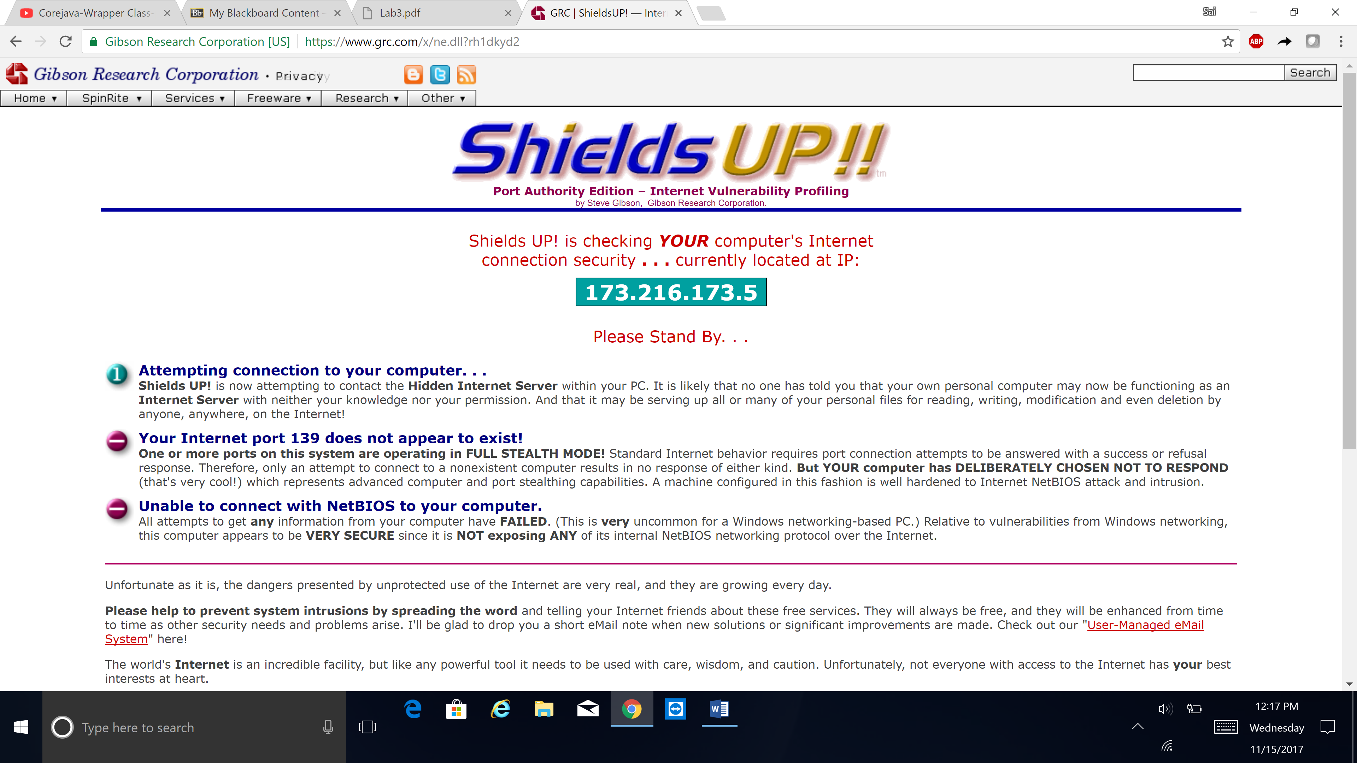

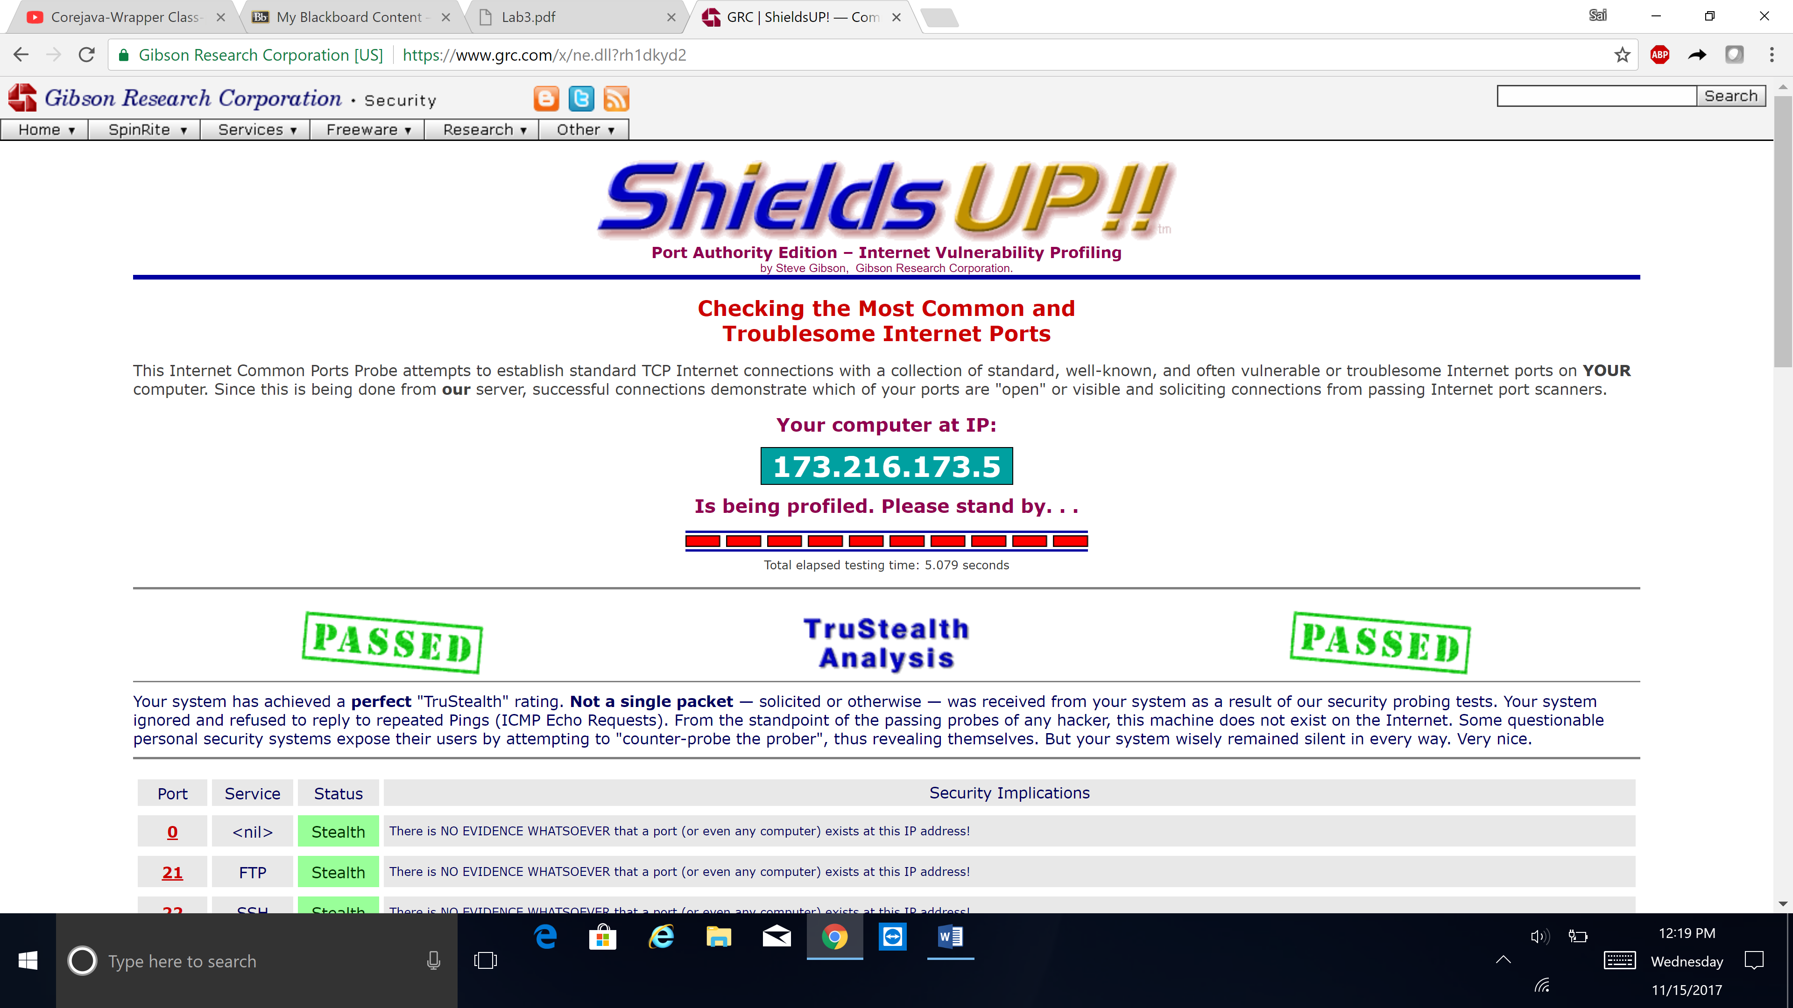

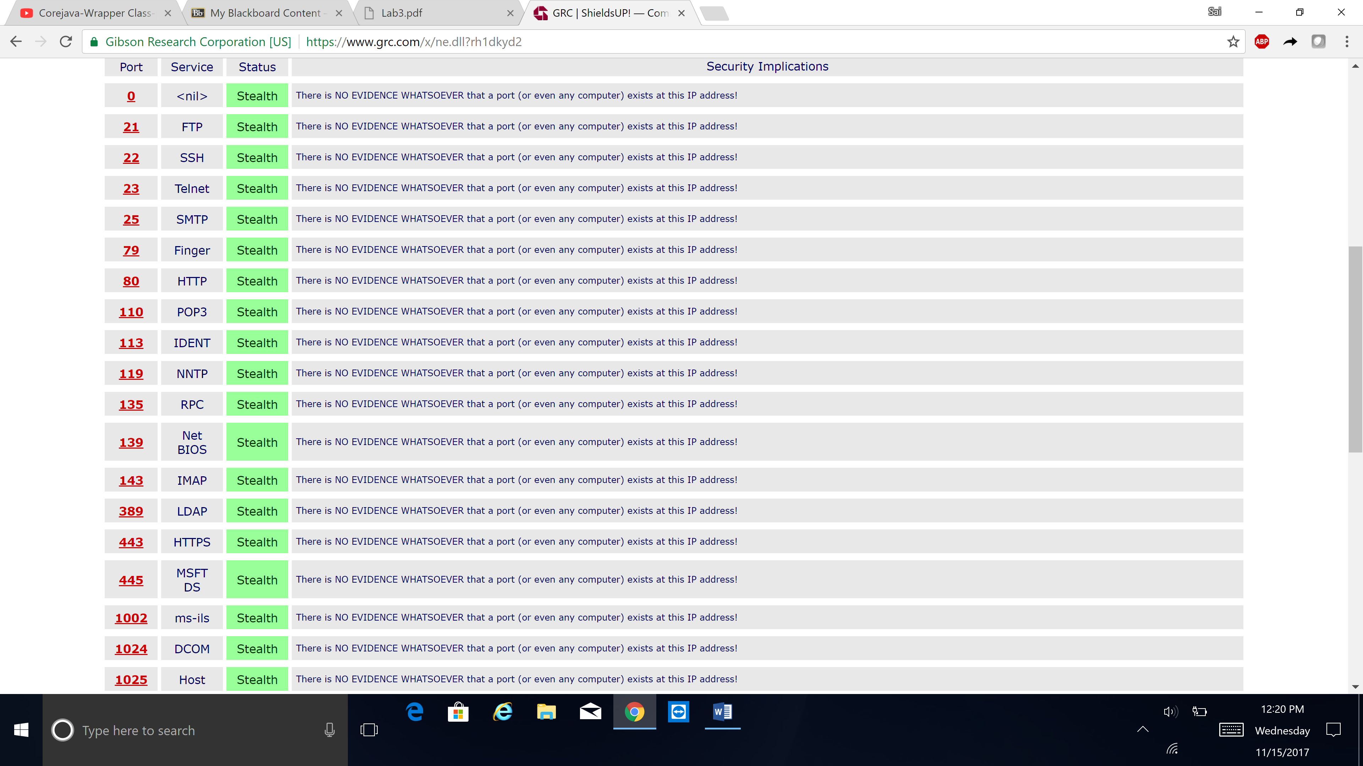

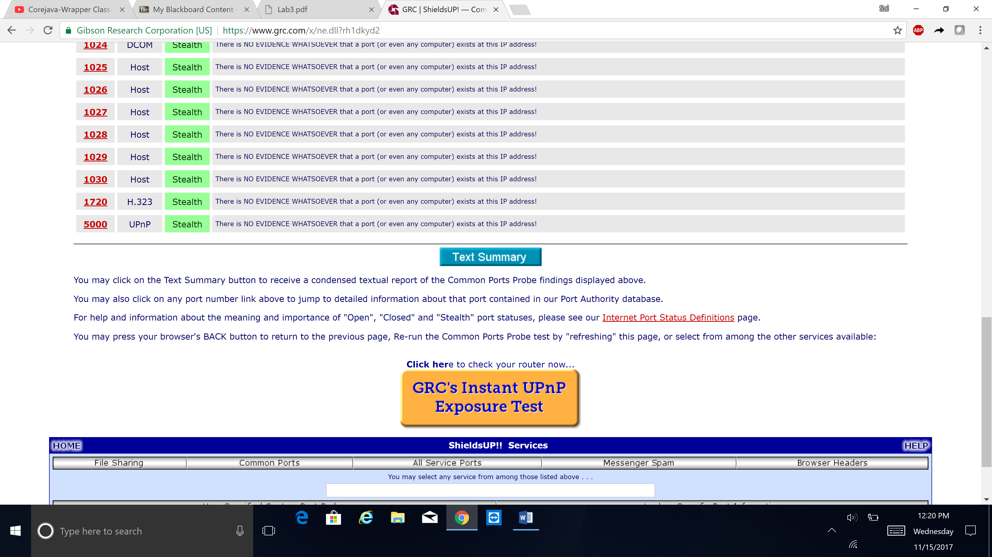

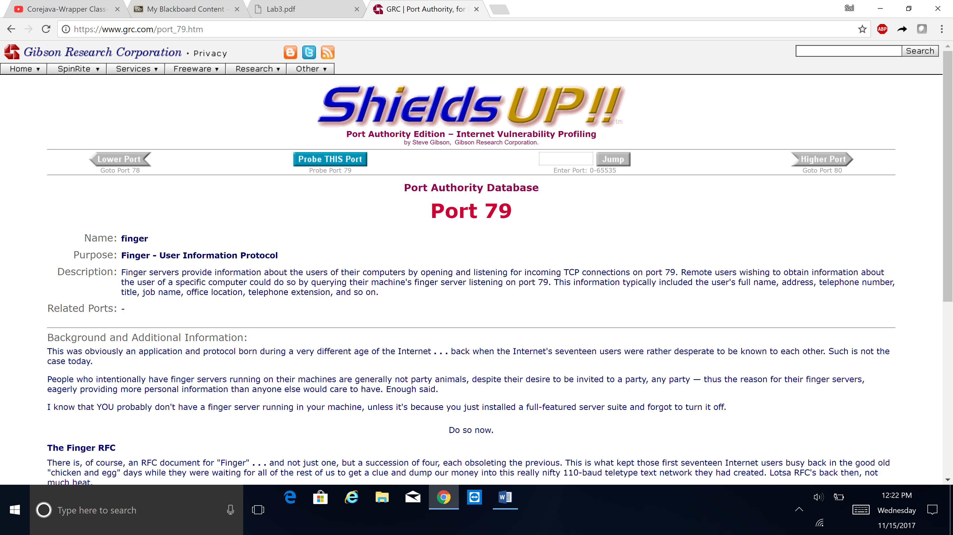

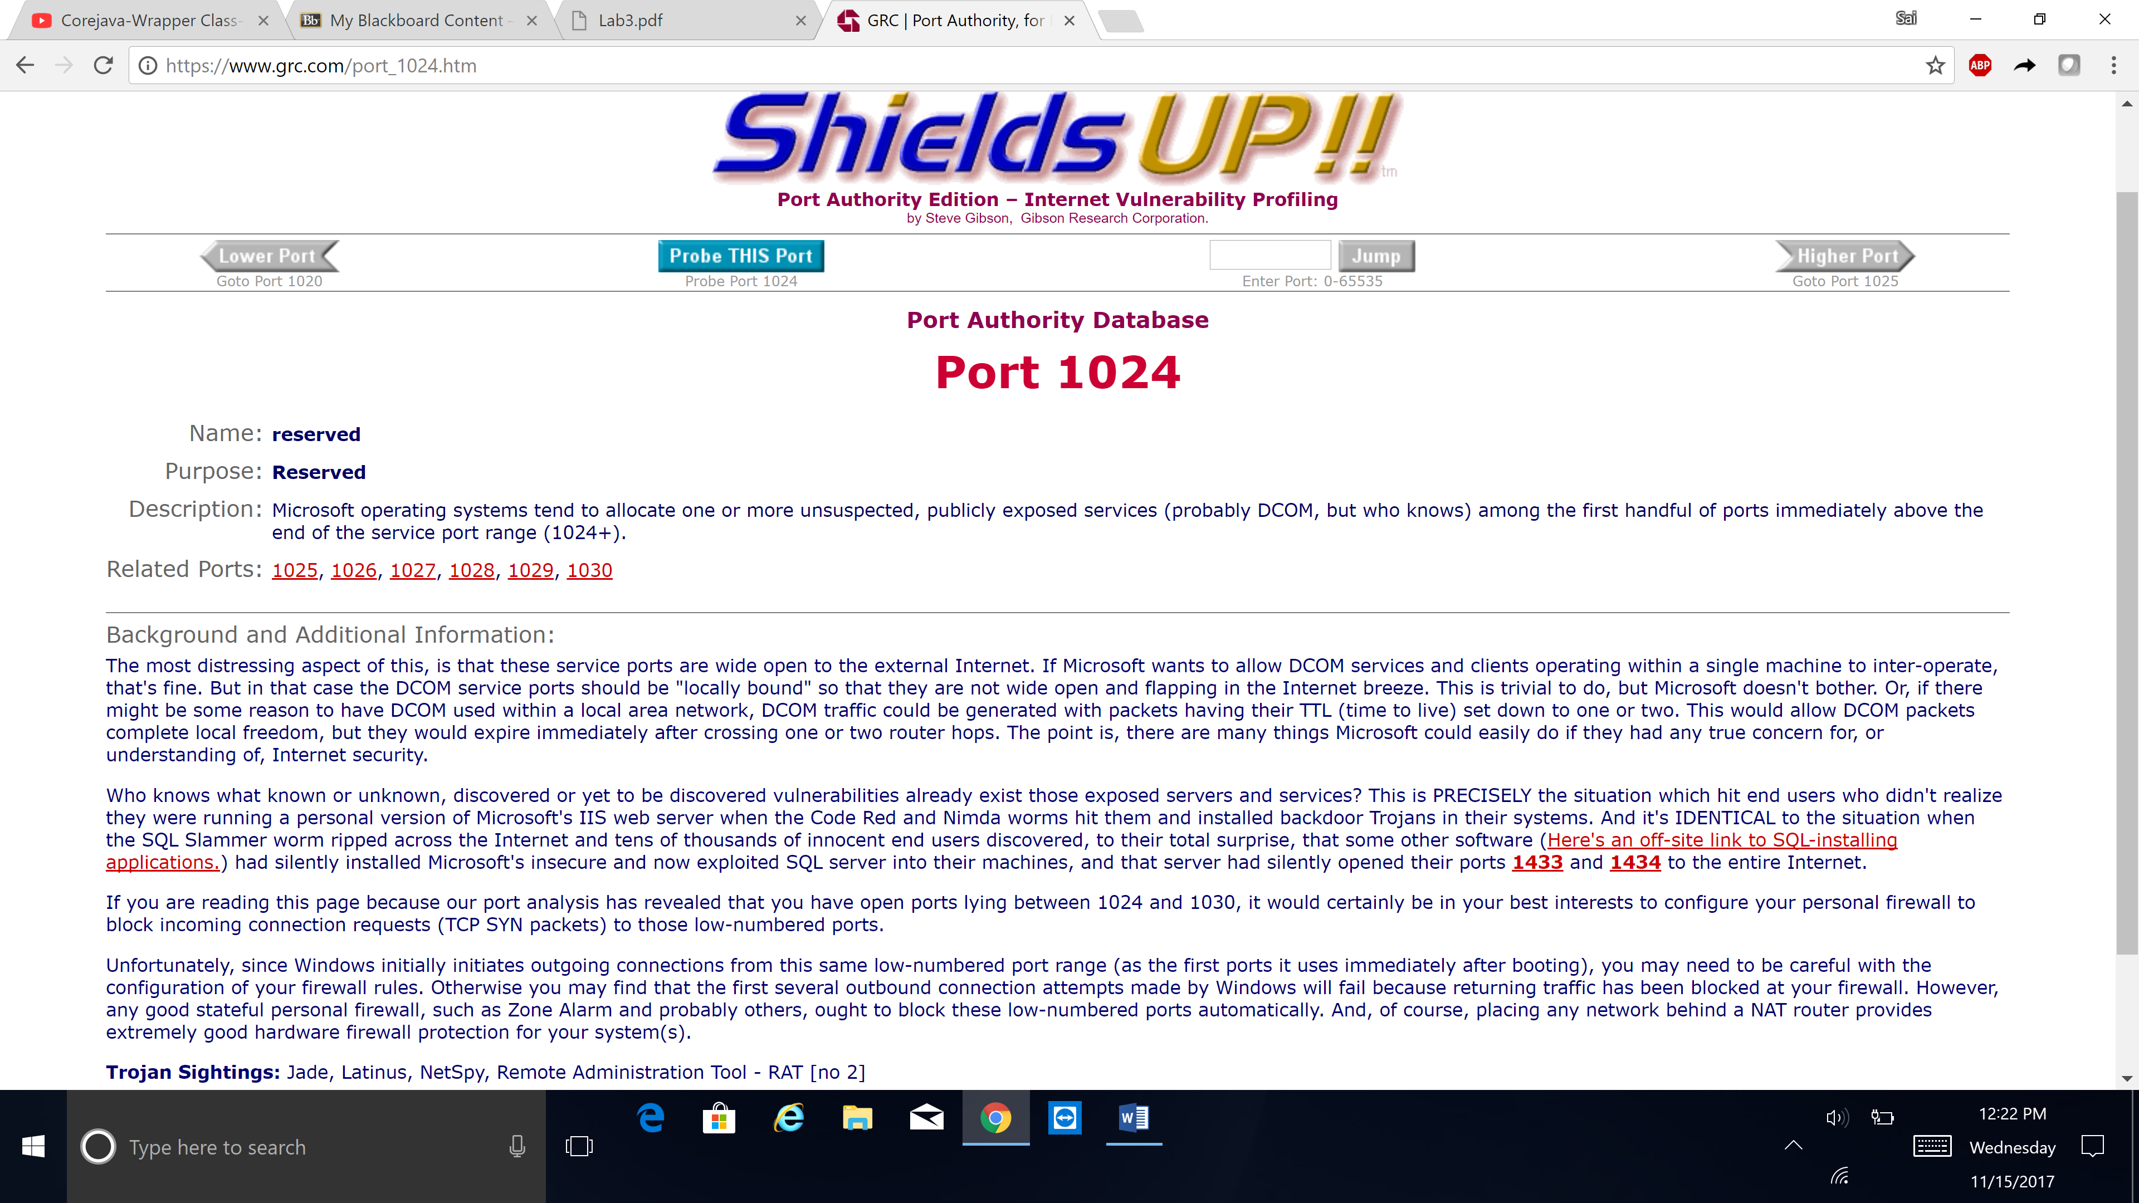

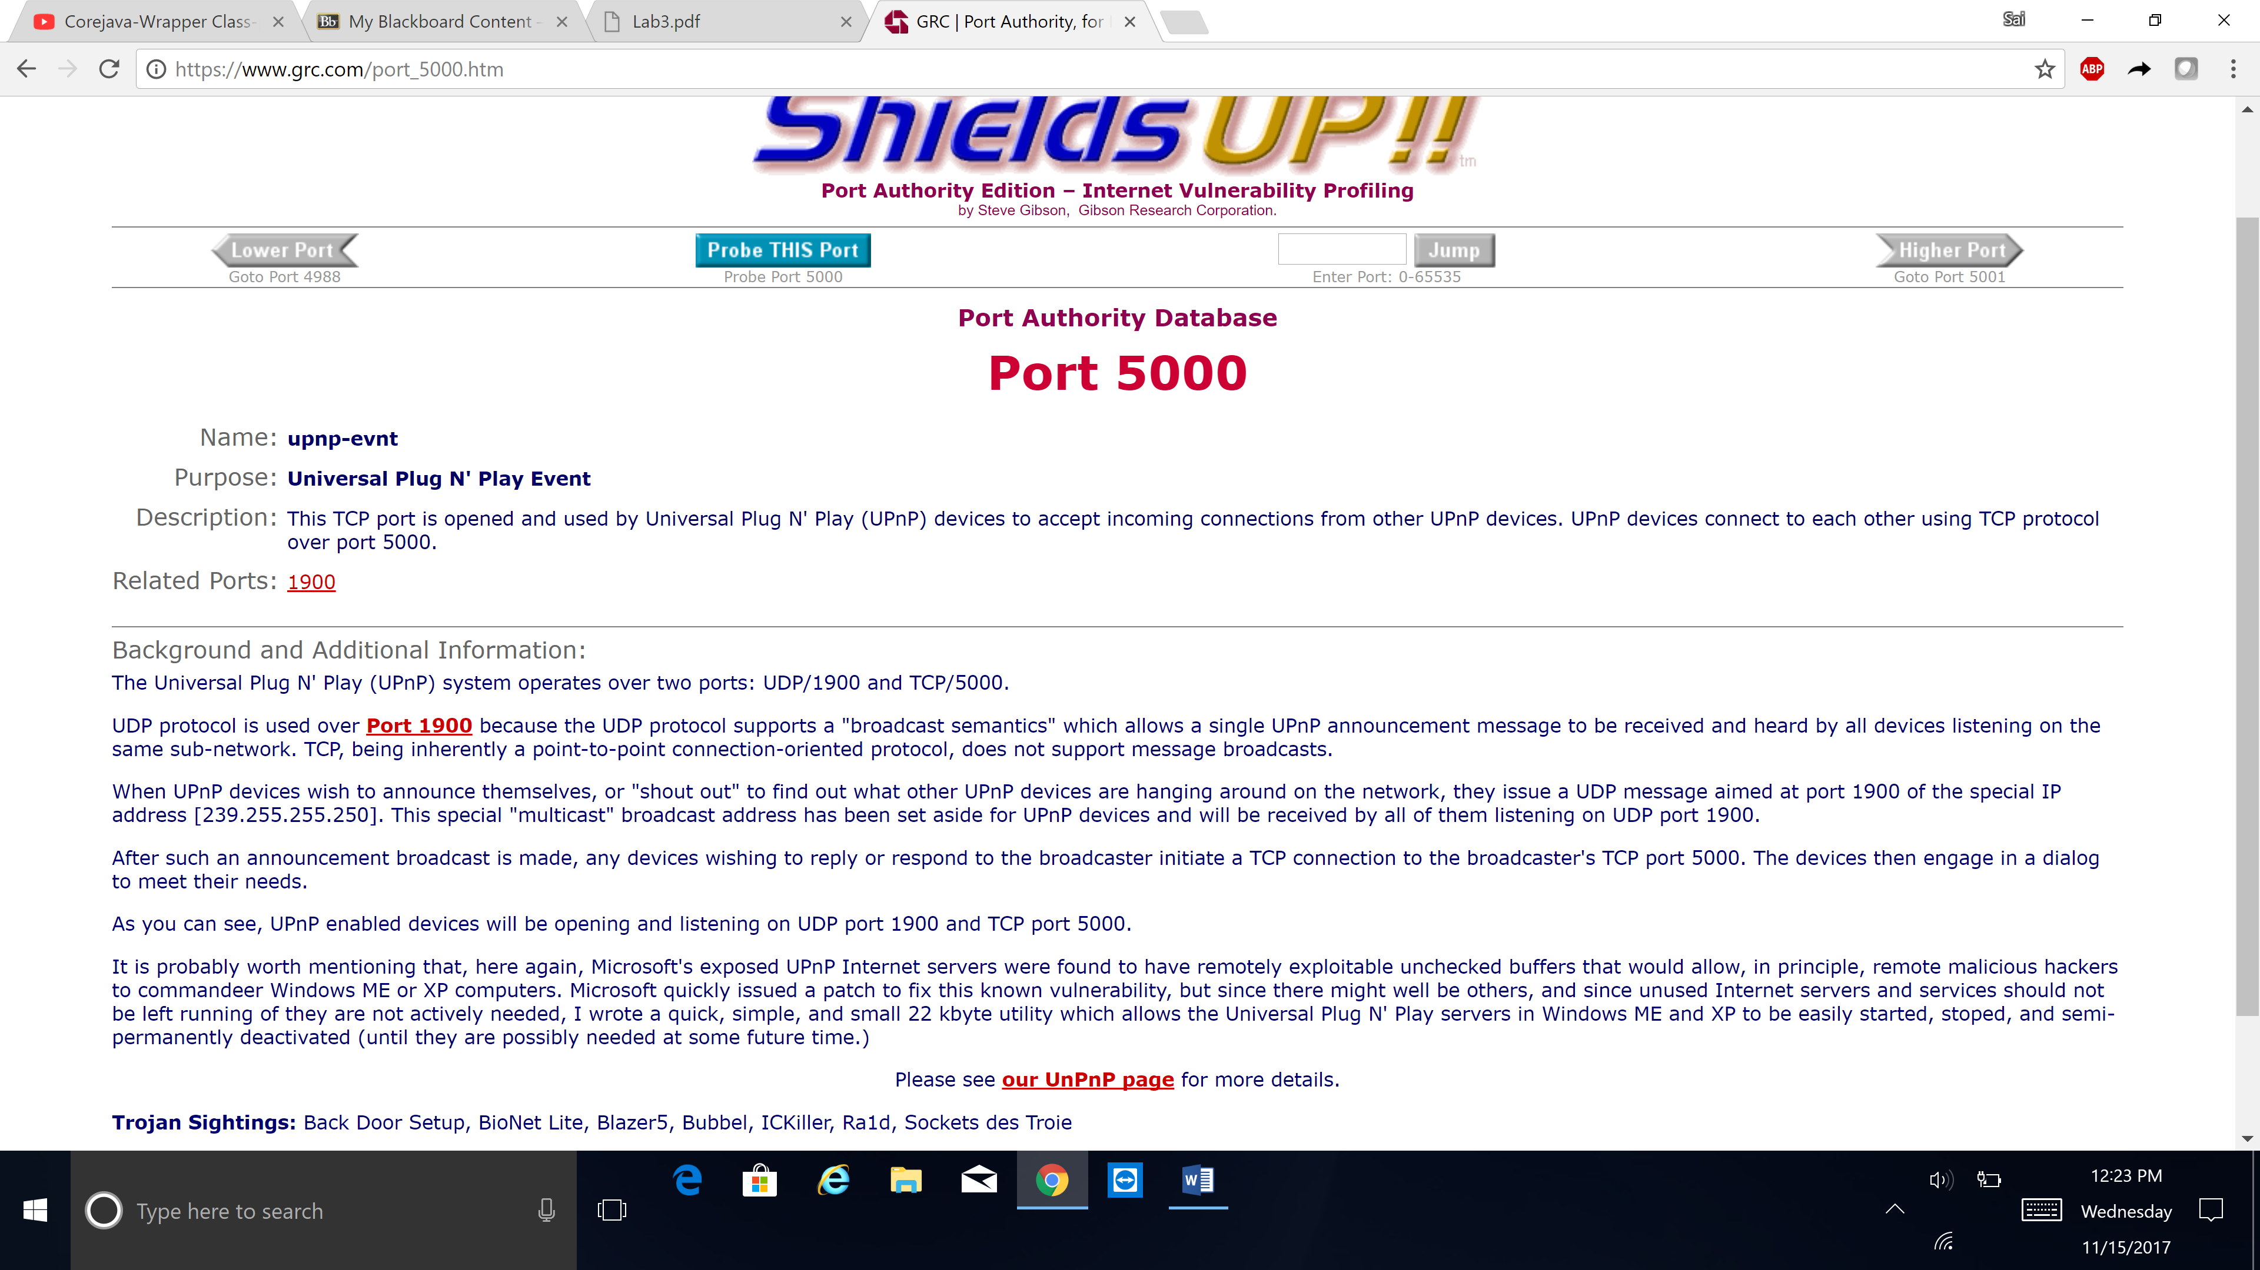

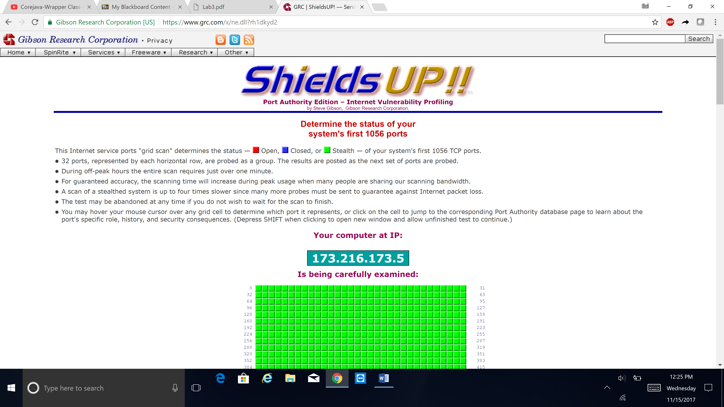

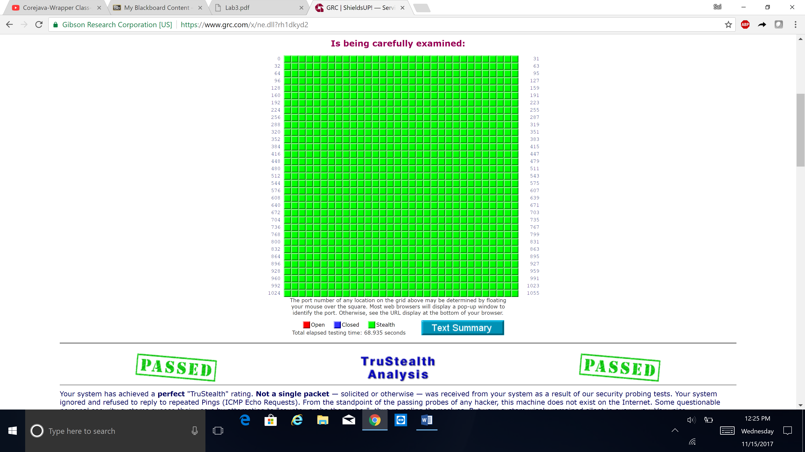

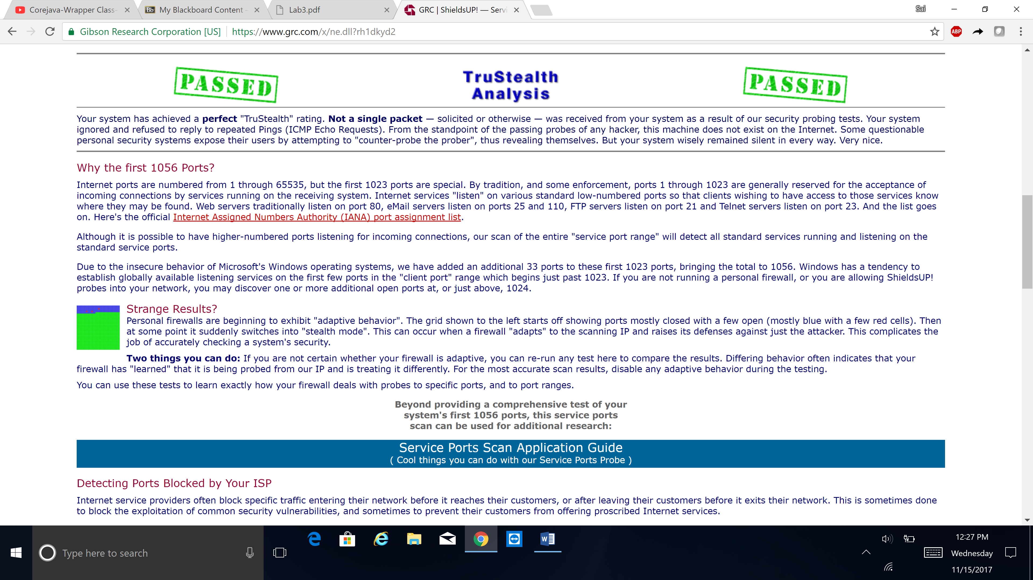

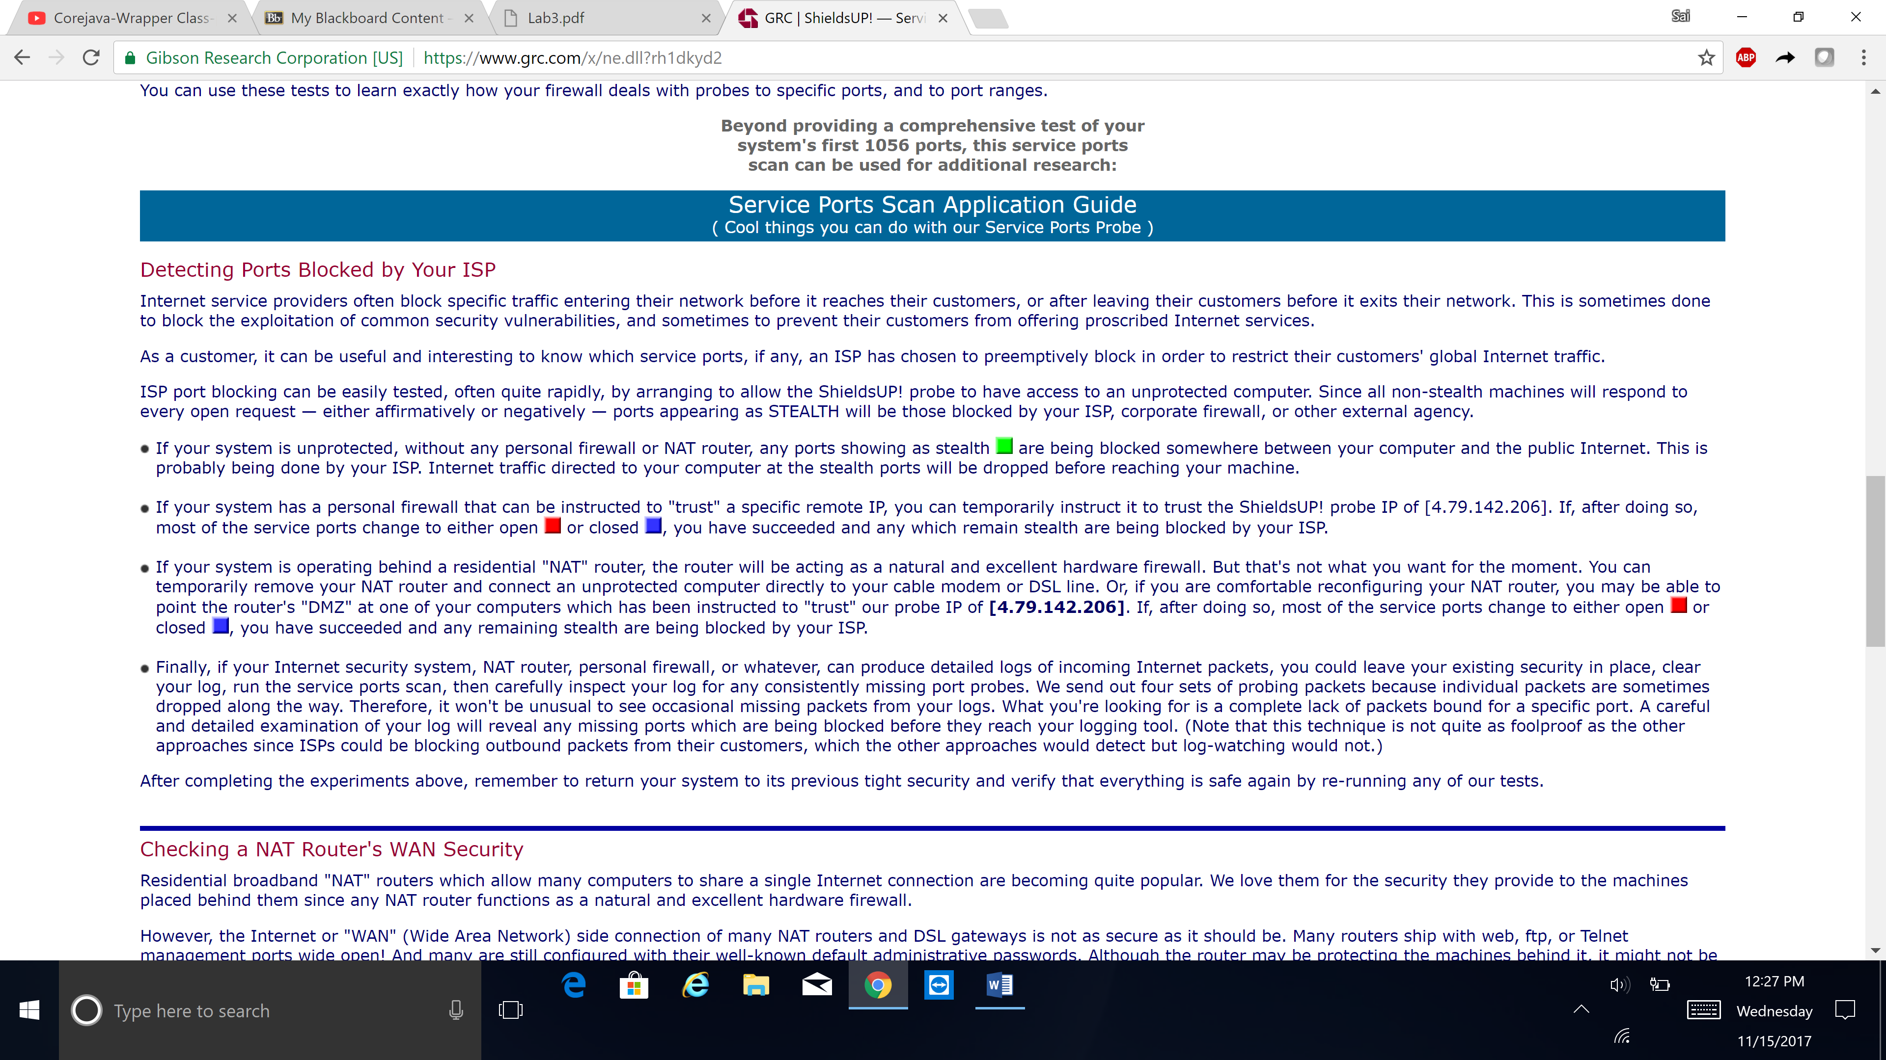

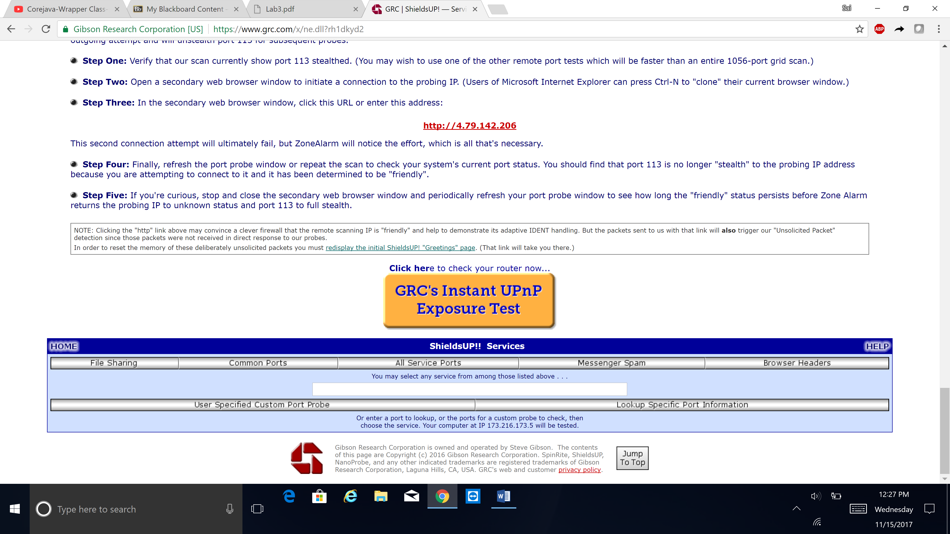

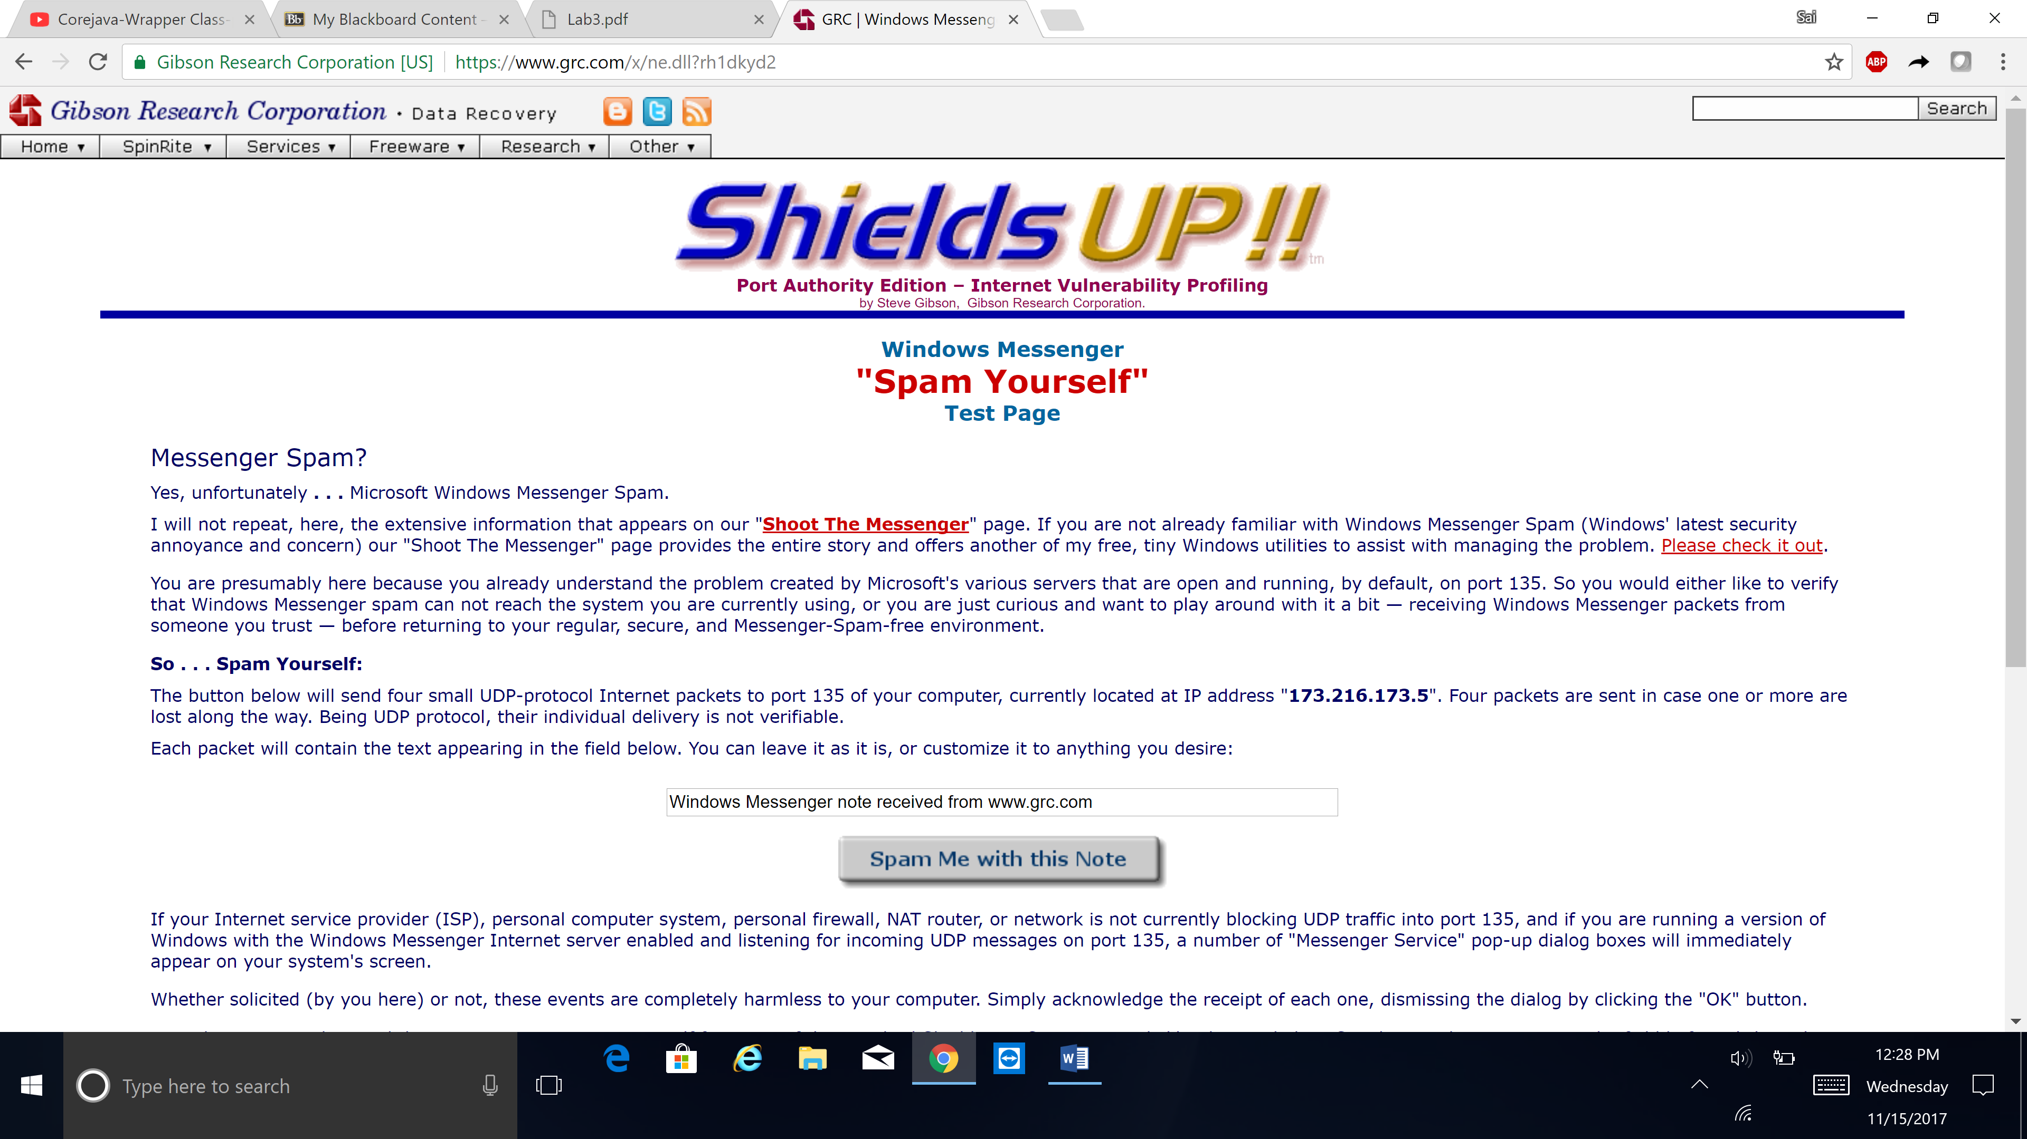

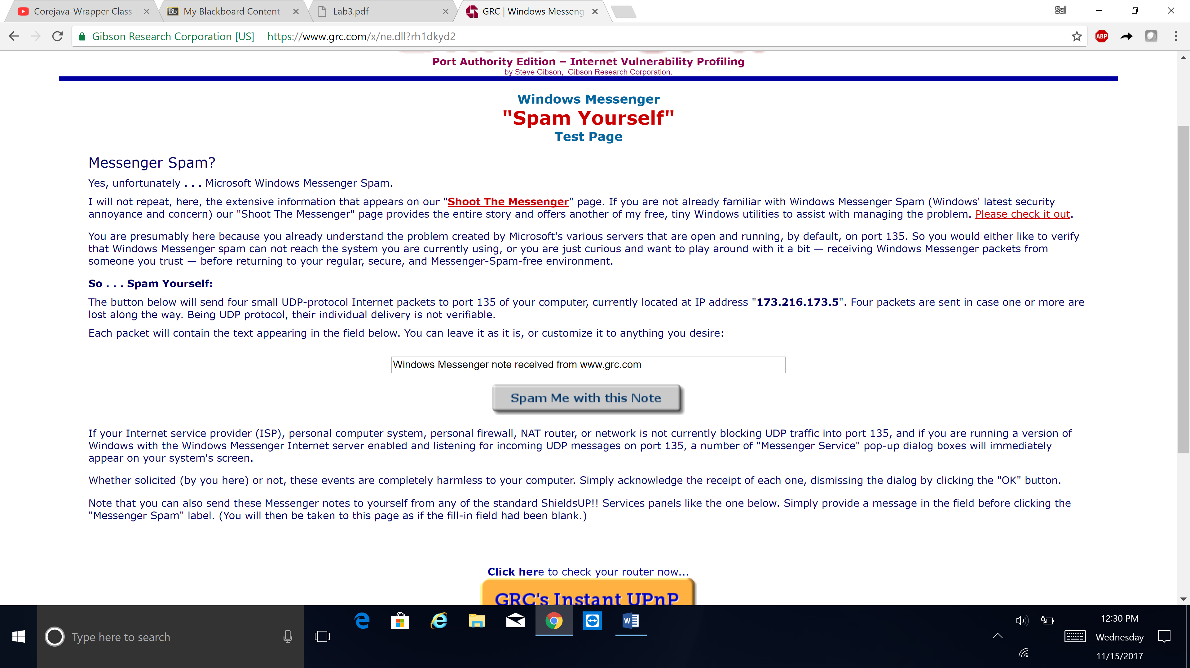

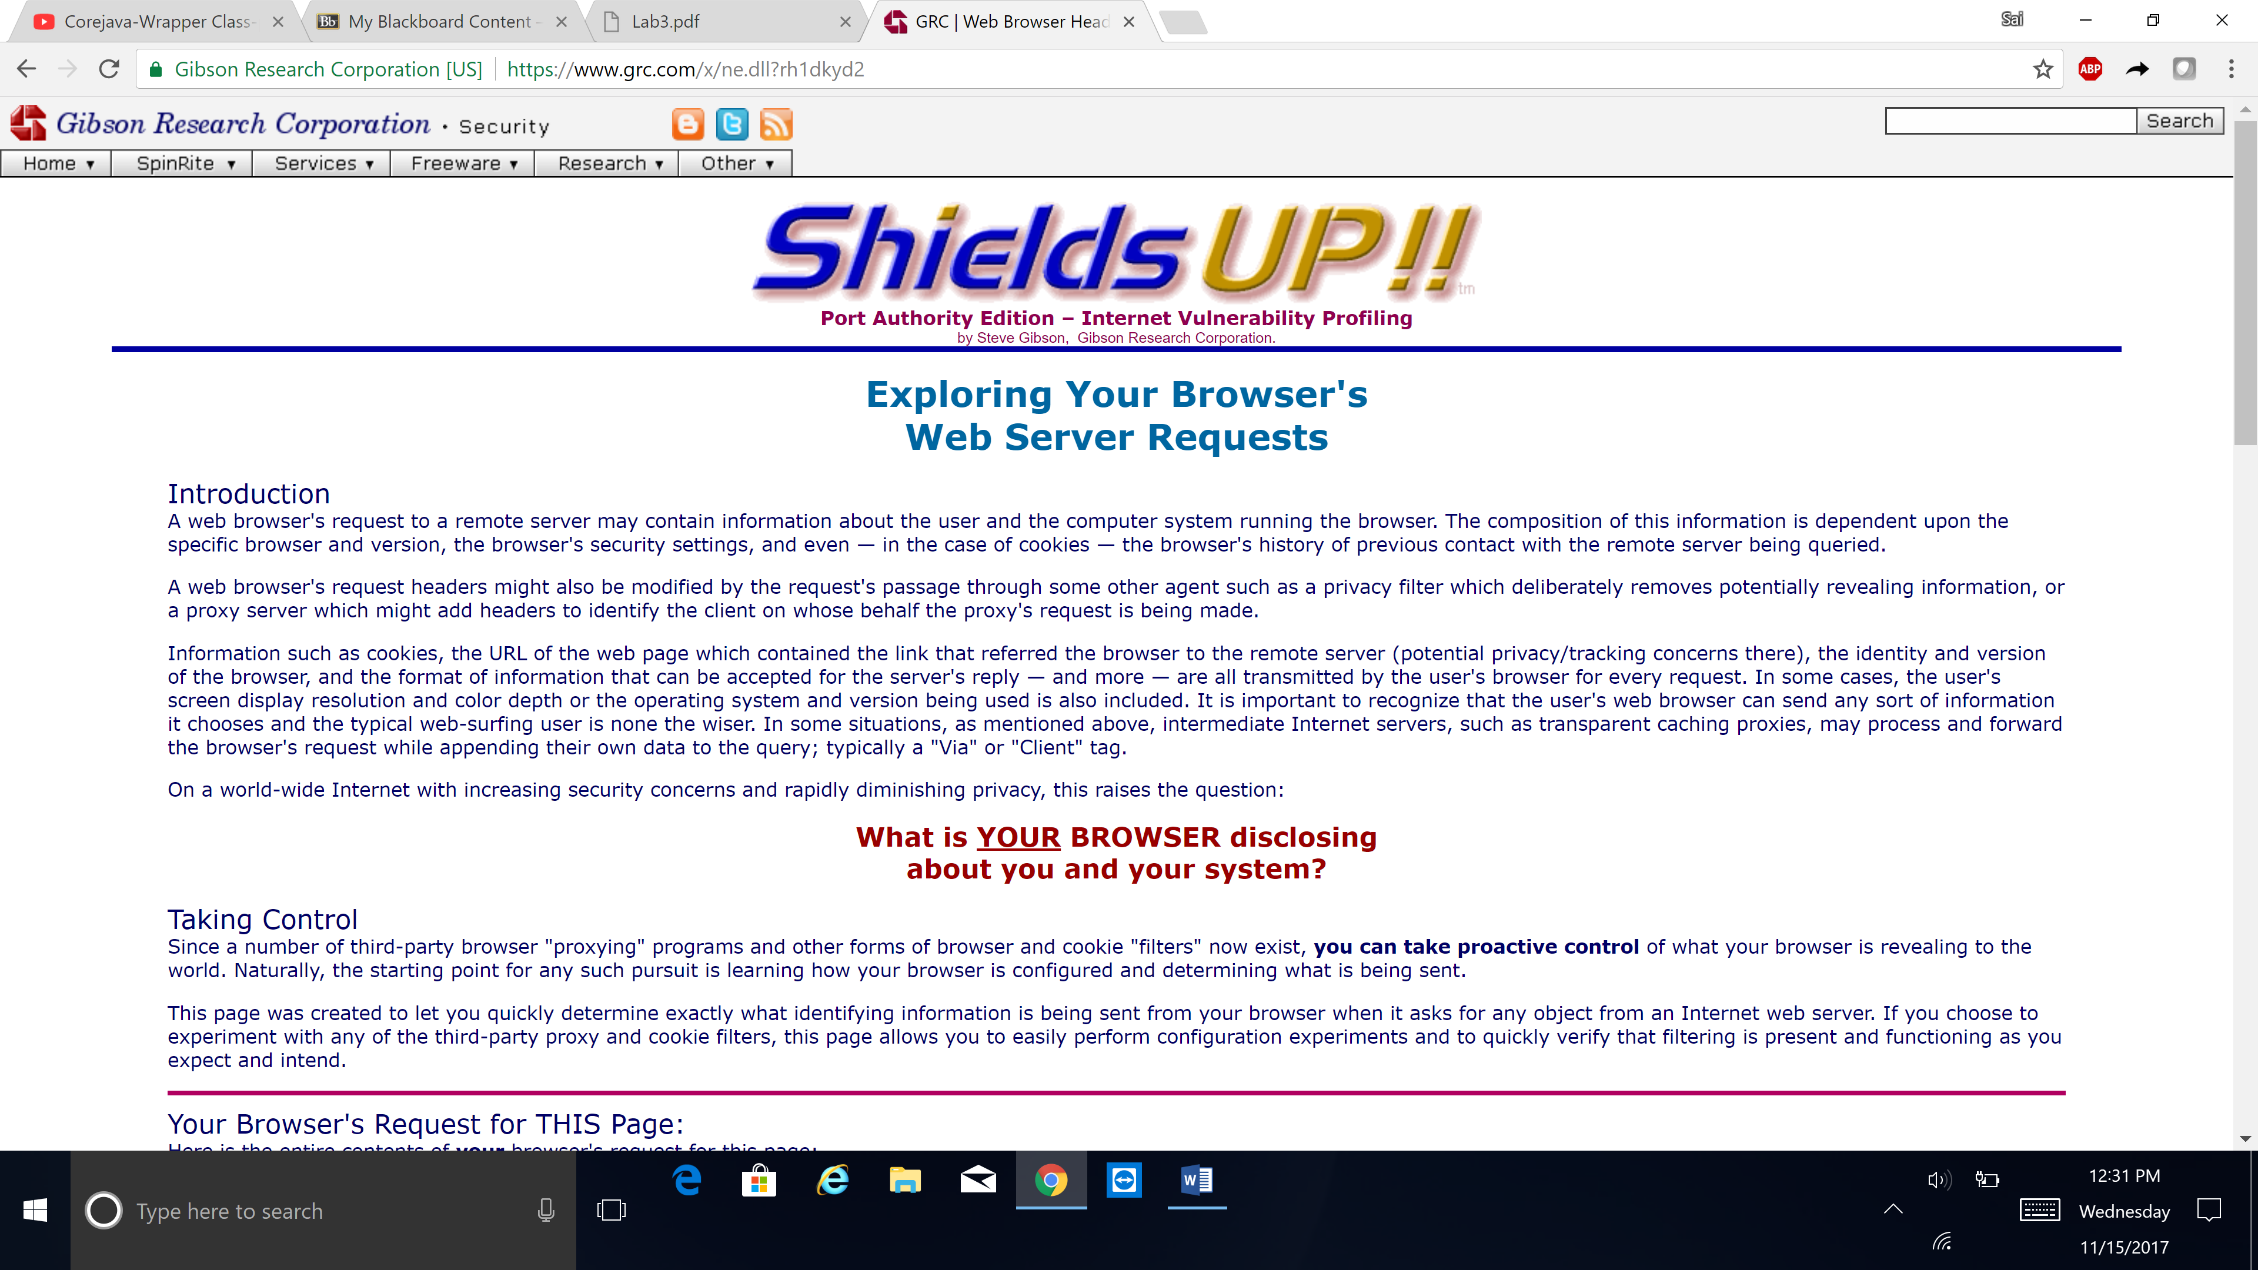

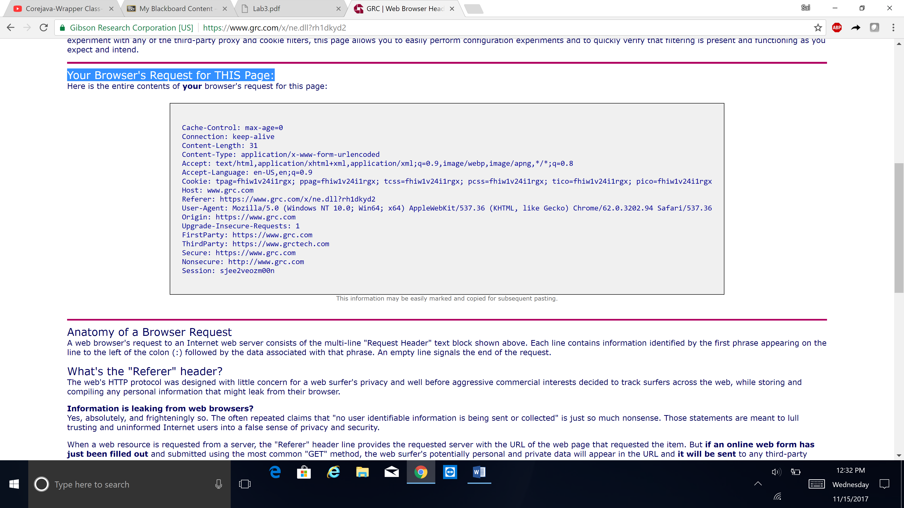

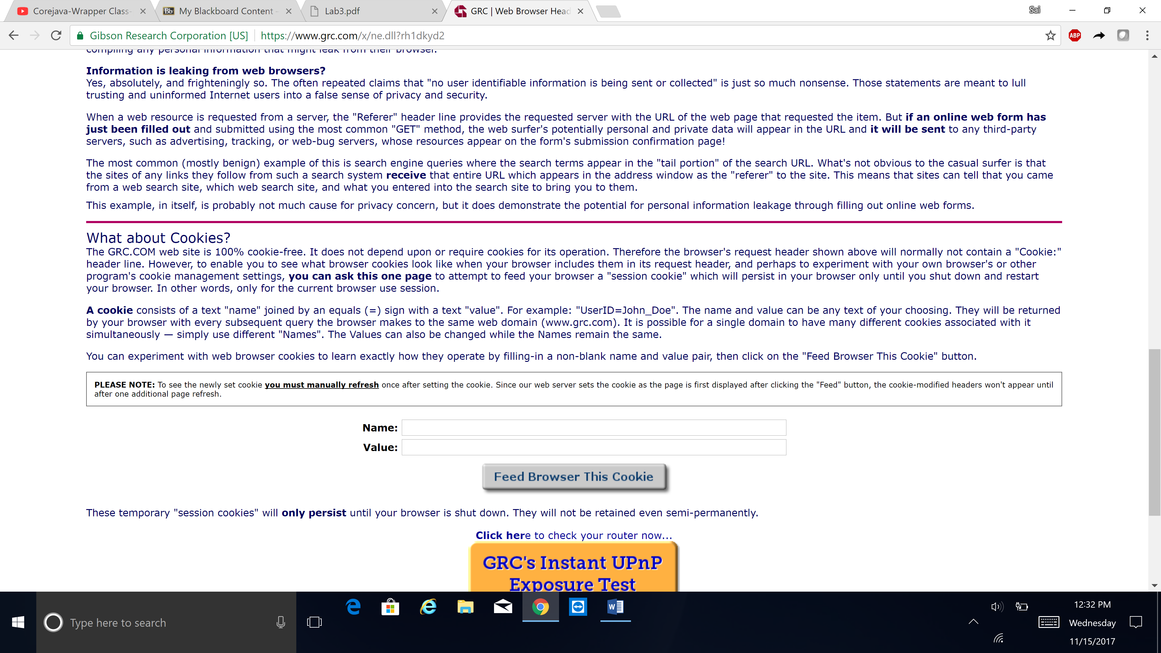

**22.**

1. shields UP! Is checking my computer’s internet connection security and attempting to contact the **Hidden Internet Server** within my PC in its located my IP address 173.216.173.5
2. This Internet Common Ports Probe attempts to establish standard TCP Internet connections with a collection of standard, well-known, and often vulnerable or troublesome Internet ports on **my** computer. my system has achieved a **perfect** "TruStealth" rating.
3. This Internet service ports "grid scan" determines the status of my system's first 1056 TCP ports weather it is Open, Closed, or Stealth. Microsoft Windows Messenger Spam
4. Exploring my Browser's Web Server Requests. Since a number of third-party browser "proxying" programs and other forms of browser and cookie "filters" now exist, I **can take proactive control** of what your browser is revealing to the world.

**23.**

**a. Yes.**

**b. Yes,** malware could rename itself. But it doesn’t mean that it should make it through the firewall. It depends on the type of firewall, and the specific functionality of that firewall.